

**OBJECTIVE**

To identify Arithmetic Progressions in some given lists of numbers (patterns).

**METHOD OF CONSTRUCTION**



Cardboard, white paper, pen/pencil, scissors, squared paper, glue.

1. Take a cardboard of a convenient size and paste a white paper on it.
2. Take two squared papers (graph paper) of suitable size and paste them on the cardboard.

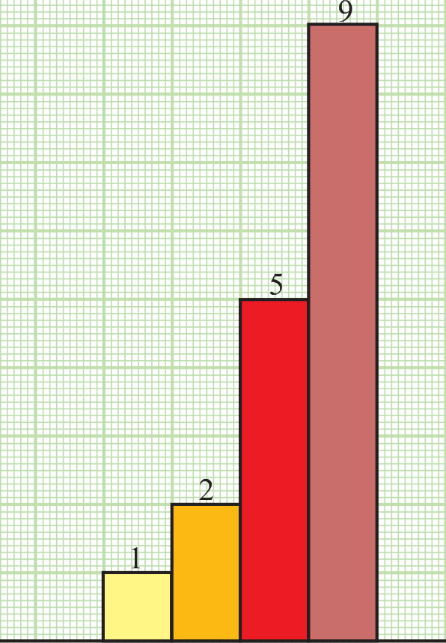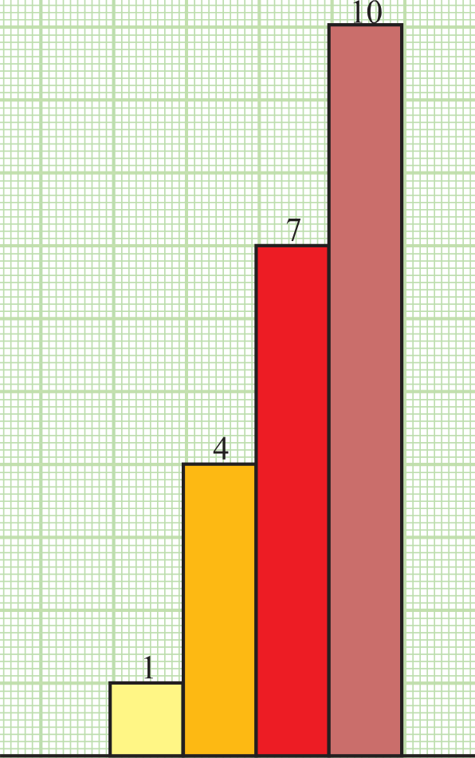

Fig. 1 Fig. 2

1. Let the lists of numbers be

(i) 1, 2, 5, 9, ....... (ii) 1, 4, 7, 10, ......

1. Make strips of lengths 1, 2, 5, 9 units and strips of lengths 1, 4, 7, 10 units and breadth of each strip one unit.
2. Paste the strips of lengths 1, 2, 5, 9 units as shown in Fig. 1 and paste the strips of lengths 1, 4, 7, 10 units as shown in Fig. 2.

DEMONSTRATION

1. In Fig. 1, the difference of heights (lengths) of two consecutive strips is not same (uniform). So, it is not an AP.
2. In Fig. 2, the difference of heights of two consecutive strips is the same (uniform) throughout. So, it is an AP.

**OBSERVATION**

In Fig. 1, the difference of heights of first two strips = the difference of heights of second and third strips = the difference of heights of third and fourth strips = Difference is (uniform/not uniform)

So, the list of numbers 1, 2, 5, 9 form an AP. (does/does not) Write the similar observations for strips of Fig.2.

Difference is (uniform/not uniform)

So, the list of the numbers 1, 4, 7, 10 form an AP. (does/does not)

**APPLICATION **

This activity helps in understanding the concept of arithmetic progression.

observe that if the left top corners of the strips are joined, they will be in a straight line in

case of an AP.